**FUNCTIONAL REQUIREMENT SPECIFICATIONS FOR “DISPLAY BOOKSHELVES”**

Submitted to:

Cognizant Technology Solutions (CTS)

***Submitted by***

|  |  |
| --- | --- |
| **Name** | **Employee ID** |
| Gyanraj Hansdah | 2361781 |

For more information, please visit on website:

[**https://**](https://urbanladder.com/)**www.pepperfry.com**

**TABLE OF CONTENTS**

**1. INTRODUCTION**

1.1 Purpose 3

1.2 Intended Audience 3

1.3 Project Scope 3

**2. GENERAL DESCRIPTION**

2.1 Product Context 4

2.2 Overview of Functional Requirement 4

2.3 Operating Environment 5

**3. REQUIREMENT**

3.1 External Interface Requirements 5

3.2 Functional Requirements 6

3.3 Performance Requirements 13

3.4 Security 13

3.5 Usability 14

3.6 Other Requirements 14

1. **INTRODUCTION**

The functional requirement document is a complete description of the new feature of the “pepperfry.com” website. This document also describes the user interaction and the response of the webpage UI.

* 1. Purpose:

The purpose of this document is to give functional requirements for “Bookshelves Details” in Pepperfry website. Also, this document will help the audience to understand the behavior of the application for development.

* 1. Intended Audience:
* Business Unit (BU) person
* Academy Coach
* Technical Trainer
* Project Team
  1. Project Scope:

This document defines at a functional level, the business activities that are encompassed by the system and the rules that apply to them. It also encompasses some of the key high- and low-level technical requirements of the system.

It draws heavily on both proposed Framework and Business Rules and the Technical Architecture documents. The scope of the detailed analysis project phase specifies that this document will include:

* Classification of requirements according to their functional areas.
* A description of each process in the system, including their inputs, outputs, and data transformation rules.

1. **GENERAL DESCRIPTION**
   1. Product Context:

Pepperfry.com is a furniture online shop. It gives news about different types of furniture set like Bookshelves, Study Chairs, Study Tables, Beds, Dining etc. and their updates. It also provides price, features, and material type.

* 1. Overview of Functional Requirements:

Display Bookshelves:

* Search for bookshelves
* Click on “search” button. It will navigate to the next page.
* Select category as “Bookshelves”
* Display the first 3 bookshelves under recommended category and price below 15,000.

Luxury List:

* Move the cursor to the Luxury tab.
* Retrieve the sub-menu items under Luxury tab.

Gift Cards:

* Click on the “Gifts” button on the webpage.
* Choose the occasion as birthday/anniversary.
* Fill the invalid details and check whether error message is displayed or not.
* Fill the denomination.

Study Chairs:

* Search for “study chairs”
* Click on “search” button. It will navigate to the next page.
* Display the first 3 study chairs with highest Customer Ratings.
  1. Operating Environment:
* Processor : Intel Core
* RAM : 4 GB or above.
* OS : Windows 8 or above.

1. **REQUIREMENTS**
   1. External Interface Requirements

User Interfaces:

* All users will see the same page when they enter the website.
* Login popup window will display, we will be able to login through email or Facebook or else we can close the window.
* After logging-in or closing the window, the Homepage of pepperfry.com will appear.
* The user interface is simple and easy to understand about various terminologies.

Hardware Interfaces:

* No extra hardware interfaces are needed
* The standard hardware and data communication resources will be enough.

Software Interfaces:

* OS: windows 10
* Web Browser: the system is a web-based application, client needs to choose among various browsers available such as Chrome, Firefox, MS edge etc. etc.
* The computer/laptop must have an internet connection to access the system.
  1. Functional Requirements
     1. **Description**

This part of the documentation serves to present the “pepperfry.com” to display bookshelves, display study chairs, display sub-menus in Luxury tab and functionality of Gift cards.

* + 1. **Display Bookshelves**
* Open [www.pepperfry.com](http://www.pepperfry.com) website
* Pepperfry homepage will display.

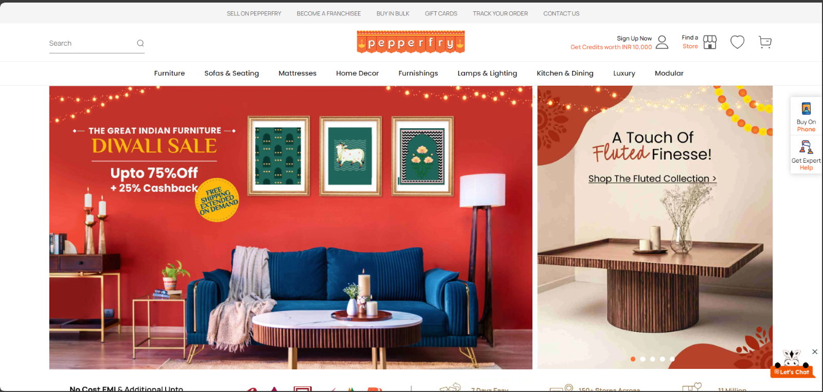

Fig: Homepage

* Search for bookshelves
* Click on “Search” button. It will navigate to next page

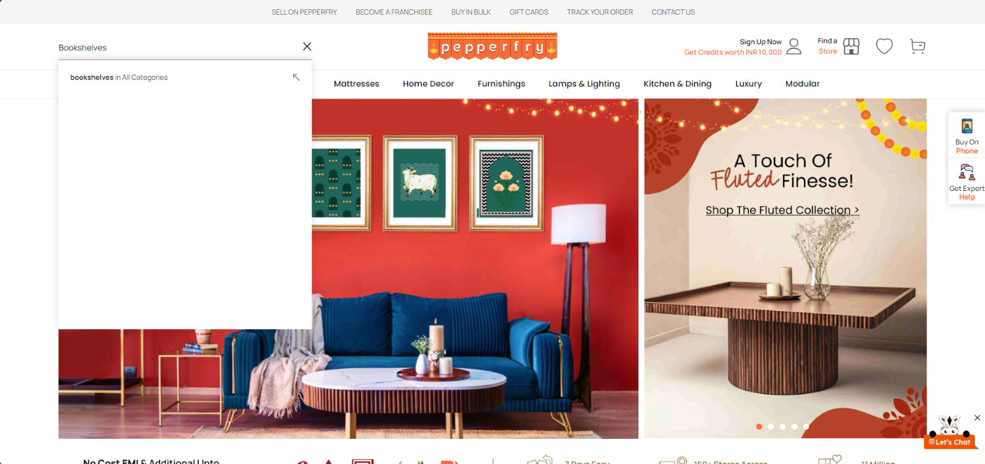

Fig: Results of Bookshelves

* Search category as “Bookshelves”
* Set the prices slider to cost below 15,000
* Display the first 3 bookshelves under 15000.

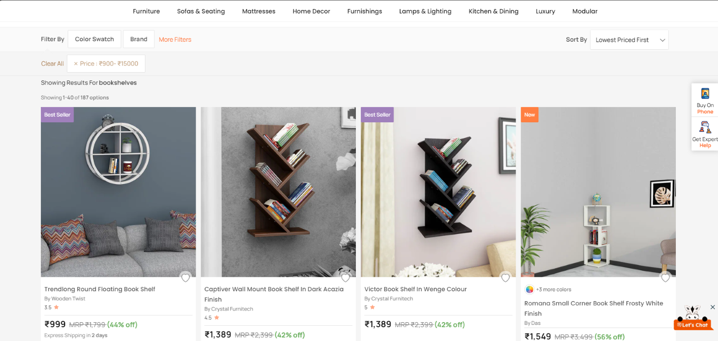

Fig: Set Category, price, storage type and Exclude out of stock

* + 1. **Display Study Chairs**
* Open [www.pepperfry.com](http://www.pepperfry.com) website
* Pepperfry homepage will display



Fig: Homepage

* Search for Study Chairs

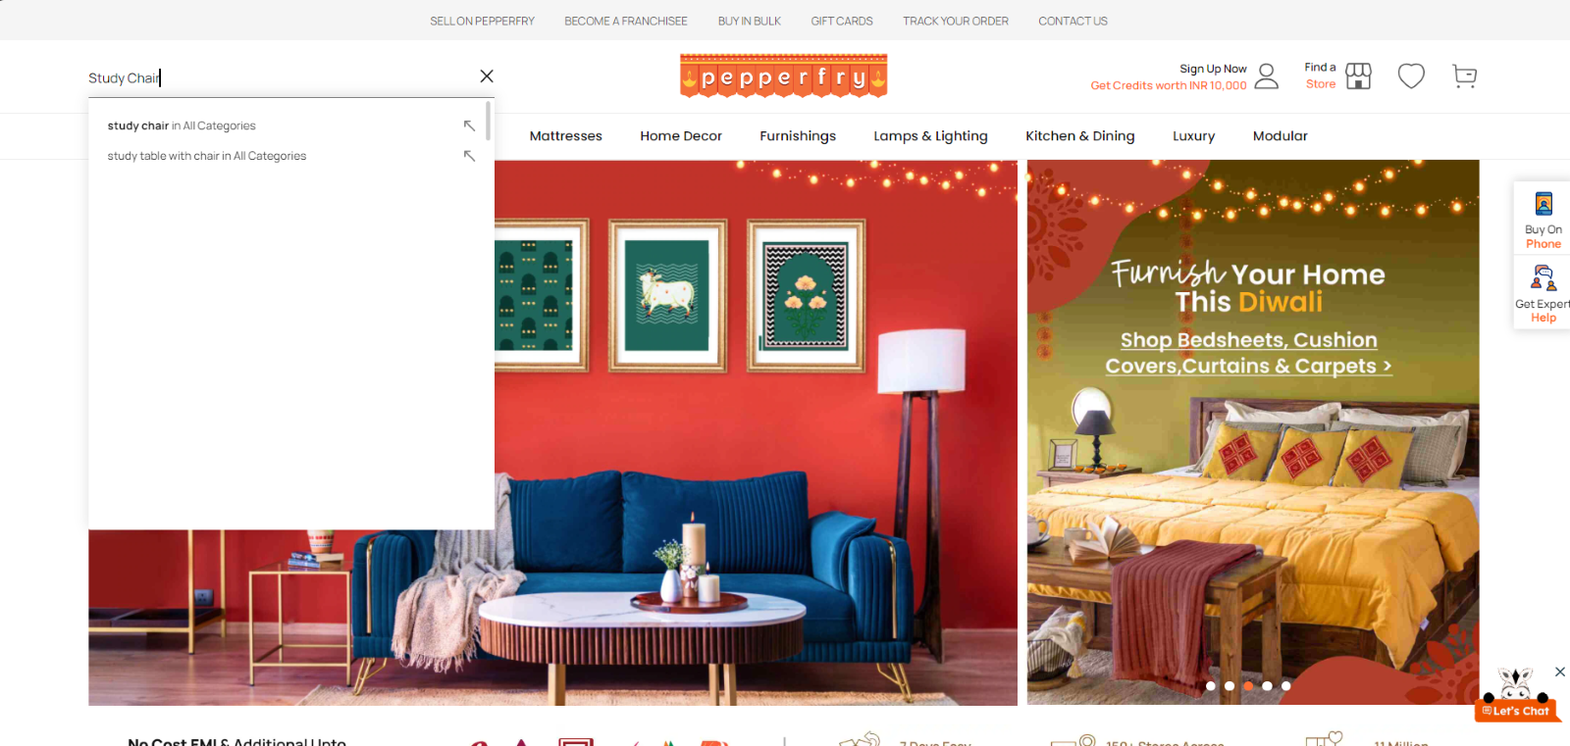

Fig: Search for Study Chairs

* Study chairs page will be displayed
* Display the first 3 study chairs with Highest Customer Ratings.

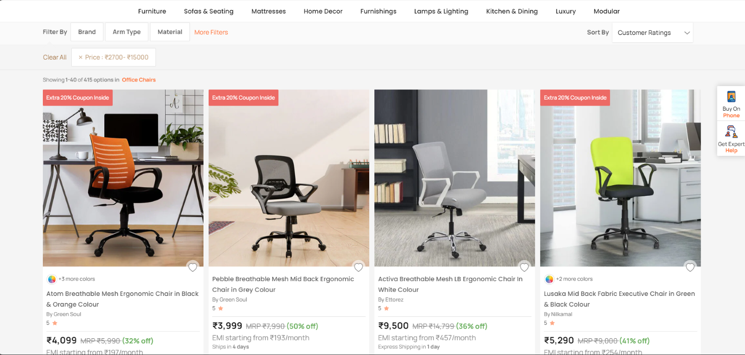

Fig: Results of Study Chair

* + 1. **Luxury Menu**
* Open [www.pepperfry.com](http://www.urbanladder.com) website
* Pepperfry homepage will display



Fig: Homepage

* Place the Luxury option
* The menu list of Luxury will display
* Store sub-menus list items and display them.

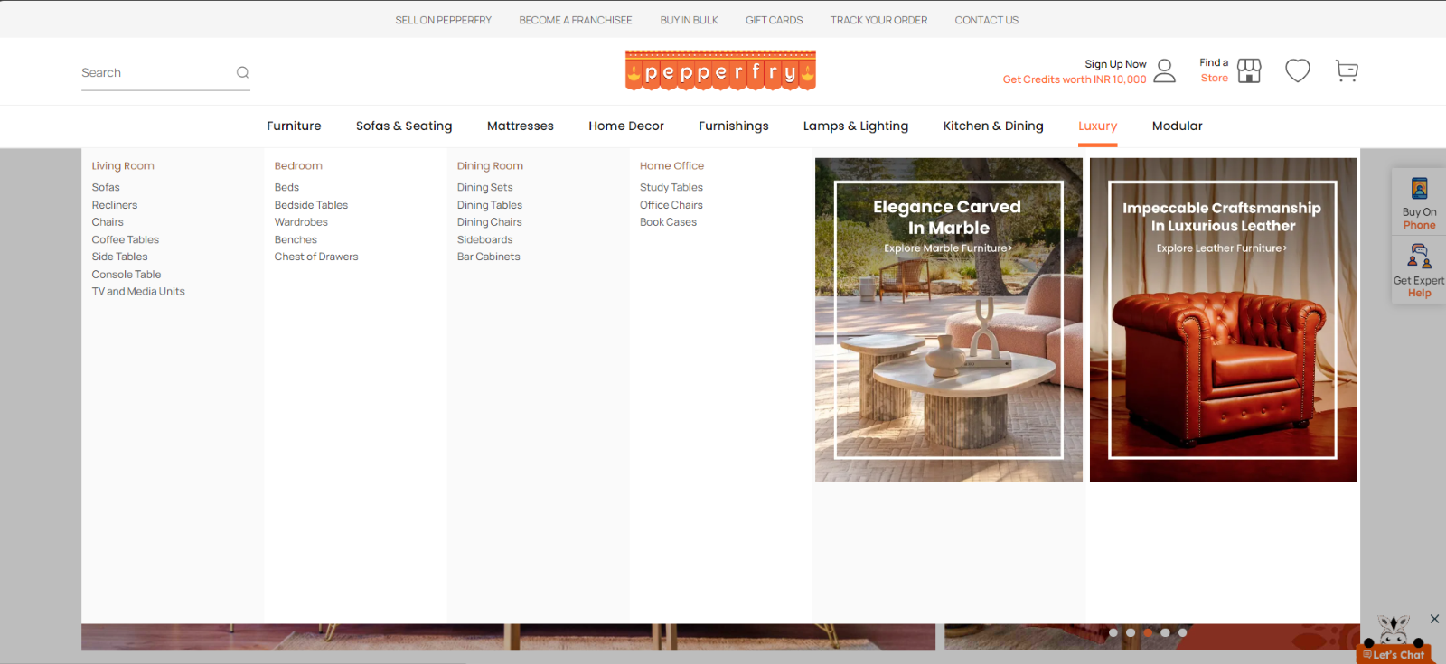

Fig: List of Luxurys

**Gift Cards**

* Open [www.pepperfry.com](http://www.urbanladder.com) website
* Pepperfry homepage will display



Fig: Homepage

* Click on gift cards
* Select Birthday/Anniversary option

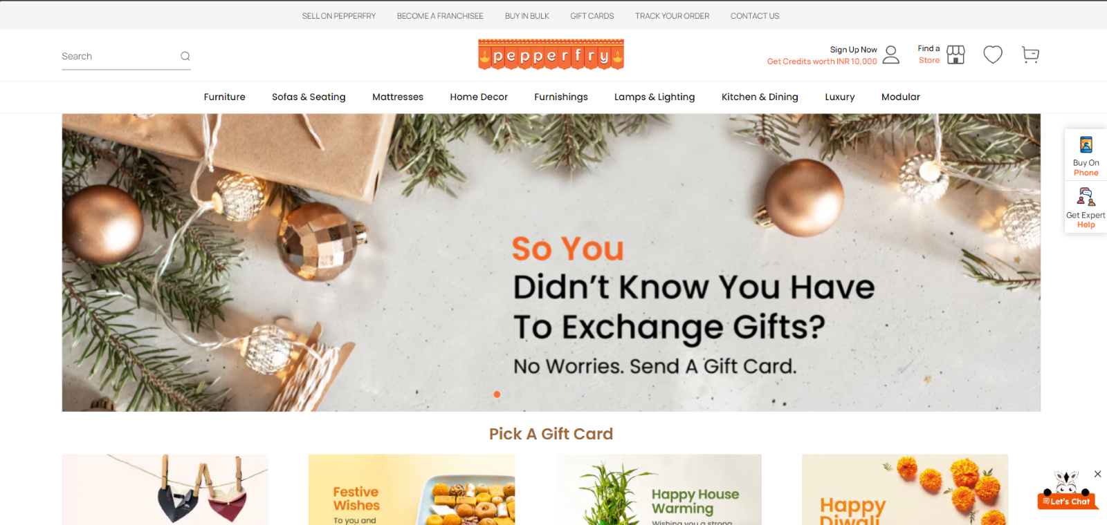

Fig: Gift card page

* Enter the amount in Customize your gift card table

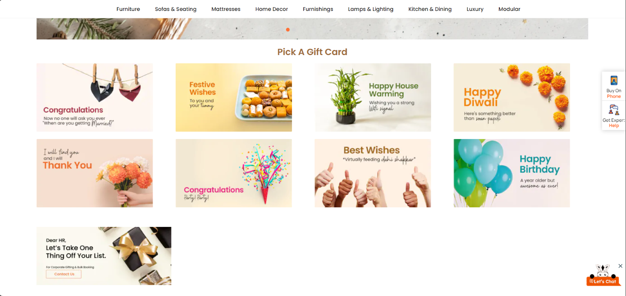

Fig: Gift card page 2

* Fill the required data in the from with valid data and in the email, field enter the invalid format.
* Click on Proceed button
* Capture the error message.

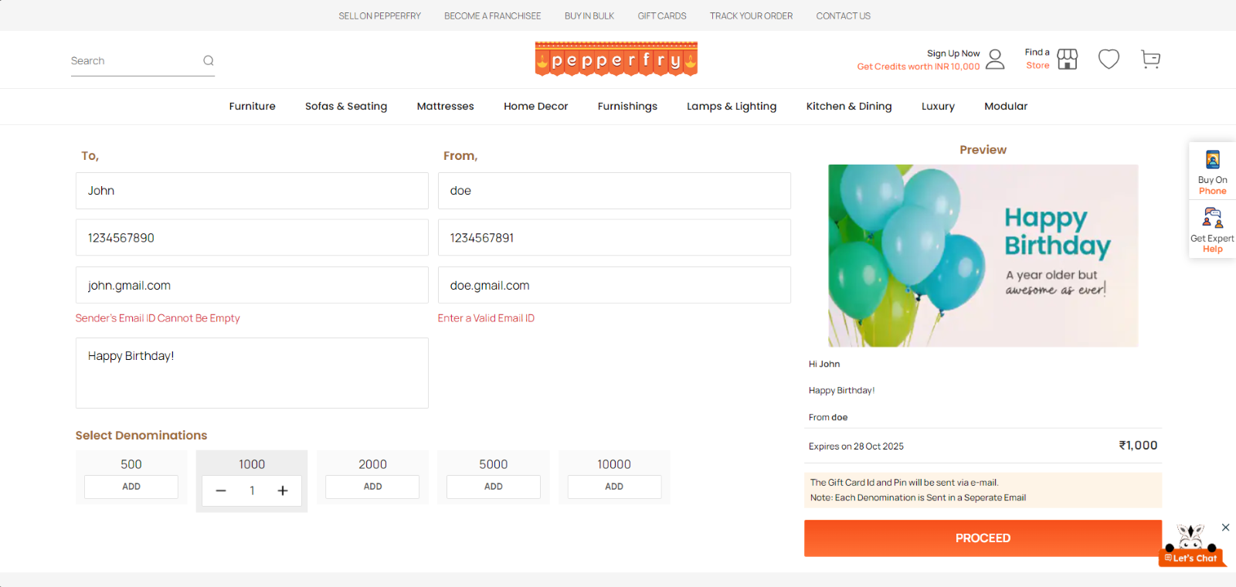

Fig: Capturing the error screenshot

## Performance Requirements

The system response time for every interaction conducted by the user should not exceed more than a minimum of 10 seconds. The system should provide a high-performance rate when executing users input and should be able to provide response within a short time span usually 50 seconds for a complicated task and 20- 25 seconds for less complicated task.

* 1. Security

The system provides authorized access; hence we can only login with valid credentials. Only users with valid login and password can login to their respective logins. If user tries to login with invalid credentials an error message will be displayed.

* 1. Usability

The system provides several options which are very easy to use. Terminology is easy so; we can interact with the application very easily.

* 1. Other Requirements

**Availability:**

The system should be available for access at 24 hours, 7 days a week. Also, in the occurrence of any major system malfunctioning, the system should be available in 1 to 2 working days, so that business process is not severely affected.

**Error handling:**

Error should be considerably minimized and an appropriate error message that guides the user to recover from the error should be provided. Validation of user’s message is highly essential.

**DISCLAIMER**

Any articles, templates, or information provided by Smart sheet on the website are for reference only. While we strive to keep the information up to date and correct, we make no representations or warranties of any kind, express or implied, about the completeness, accuracy, reliability, suitability, or availability with respect to the website or the information, articles, templates, or related graphics contained on the website. Any reliance you place on such information is therefore strictly at your own risk.